

**Locating an available charge point**

The app may be used to locate available charge points that you may wish to use.

**Browsing the map**

**Charge points** and **charging locations** are indicated on the map with the icons shown below. (Charging locations are groups of charge points located at the same site (e.g. car park).

Available charge point

Occupied charge point

Charging location (all charge points available)

Charging location (all charge points occupied)

Registration

Before using one of ChargePost’s electric vehicle charge points, we would recommend that you register an account. You may use the service without registering, however you will be required to enter your payment card each time you start a charging session.

To create a new account, you will require the following information:

Your name

Your email address

Your mobile phone number Your choice of password

You can also optionally store your payment card and vehicle details to avoid entering them when you wish start a charging session.

Your payment card Your vehicle registration

To register an account, first visit the **Account** section of the app and then tap **Create account**

Please note that guest users may register at any time without losing their session history and vehicle data.



**Starting a charging session**

**1. Connect your vehicle**

Charging location (some charge points available)

Private charge point (not for public use)

Charge point faulty

Charge point offline

Tapping either a charge point or charging location icon on the map will reveal more information about the service available.

# Searching for charge points

The search box is located at the top of the map in the **Charge** section of the app. Tap the search box to begin your search.

You can search for the name of a charge point or charging location, or a place on the map (such as a town or street name). Simply type the phrase you would like to search for. Matched results will appear beneath the search box.

An icon will indicate that the result is either a charge point, a charging location or a place on the map. Tapping on the result will navigate the map to the selected search result.

Once you have parked your vehicle in an available space, please ensure the light on the charge point labelled 'SYSTEM CHECK' is steady green. (If it is not, please use another charging bay).

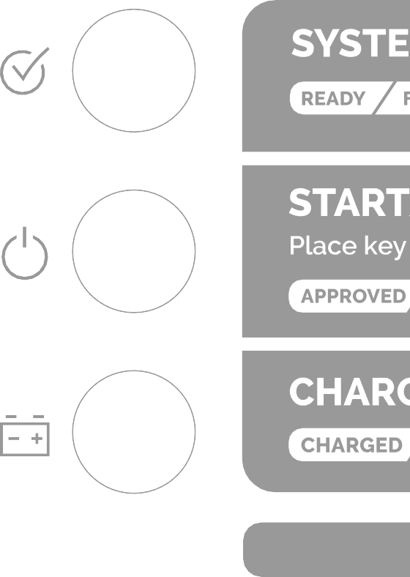

Plug one end of your charging cable into your vehicle and the other end into the charge point socket by lifting the black lid on the front of the unit.

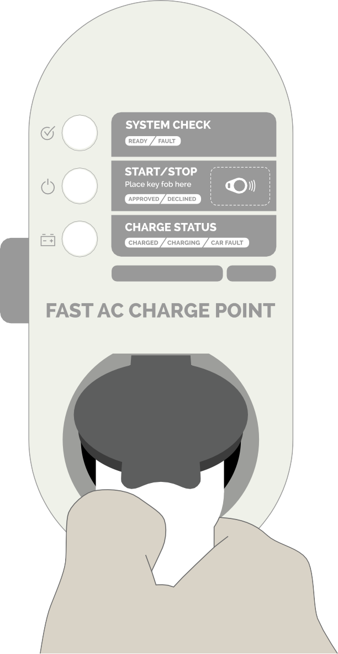

# Select the charge point in the app.

To charge your vehicle, you will need to select your chosen charge point in the app. Please refer to the section above - "Locating an available charge point" to find the your charge point or charging location on the map.

Swipe the information panel up to reveal the socket selection buttons. Please tap the button relating to the socket to which your vehicle is connected.

# Confirm your vehicle and payment card

After tapping the socket selection button to confirm the charge point, you will be asked to select your vehicle and payment card. If you have not stored any vehicles in the app, entry of your vehicle details will be optional.

Please either select a payment card if you have one saved (registered users only) or enter new payment card details if necessary.

# Enter your card CVV

You will then be required to enter the CVV (security code) of your chosen payment card

# Accept terms and conditions

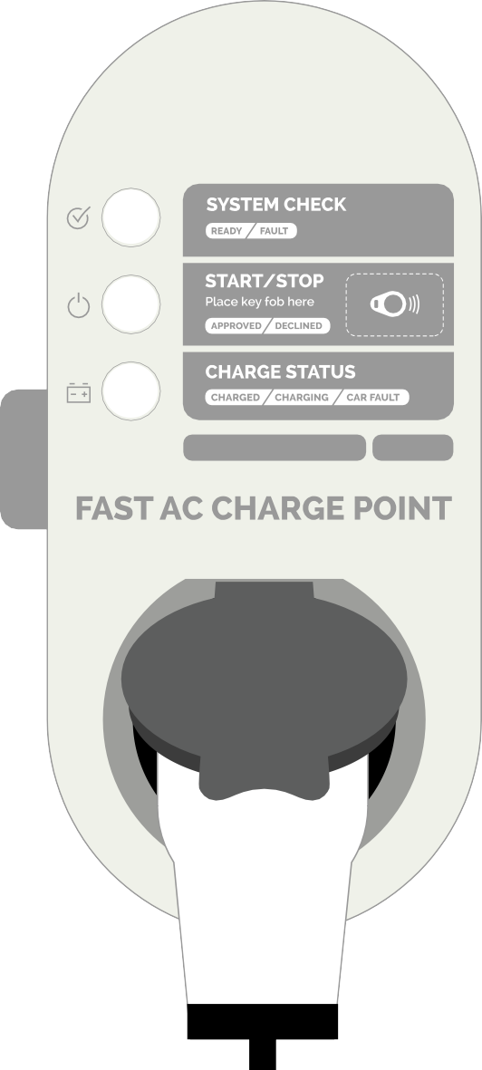

**After charging is complete**

The system will continue to charge your vehicle until you disconnect your vehicle, or when your vehicle is fully charged. When your vehicle does become fully charged, the bottom light on the charge point will glow green.

Guest users will be required to accept the terms and conditions before continuing. If the terms and conditions have been updated since last accepting them, registered users will also be required to accept the terms and conditions.

# Charging starts

After your payment card has been processed and communication with the charge point has been established, the charging session should begin.

Please note that this process may take up to a minute to complete.

When charging has commenced, you will notice that the app will display details of the current charging sesssion and the bottom light on the charge point labelled 'CHARGE STATUS' will pulse amber.

If you are subscribed to notifications, you will also receive a notification advising you that charging is complete. Please note that failure to disconnect promptly after charging is complete may result in an overstay penalty at some charge points.

Some charge points will allow to remotely stop charging and continue to park. Where this service is available, a button labelled "Stop Charging" will be displayed in the active charge session detail page of the app.

**Disconnecting your vehicle**

You may disconnect your vehicle from the charging unit at any time. **Please note that you must disconnect your charge cable from your vehicle before the cable will release from the charge point.**

Disconnecting your vehicle terminates the charging session and calculates the fee that will be charged to your payment card.

The final fee that will be charged to your payment card should display automatically in the app within a few seconds of disconnecting your vehicle.